Pizza store wants to know which pizza is fastselling and the count of that pizza  sold so far.Help them to achieve the task.

Write a query to find the highest selling pizza_name and the number of pizza's sold so far under that pizza _name category. Provide an alias for number  of pizza's sold as No.Sold.

Design Rules:

        1.Do Not Change the name of the column. Please use as per the design rules

        2.Order of the output columns: pizza_name,No.sold

Please refer to the schema:

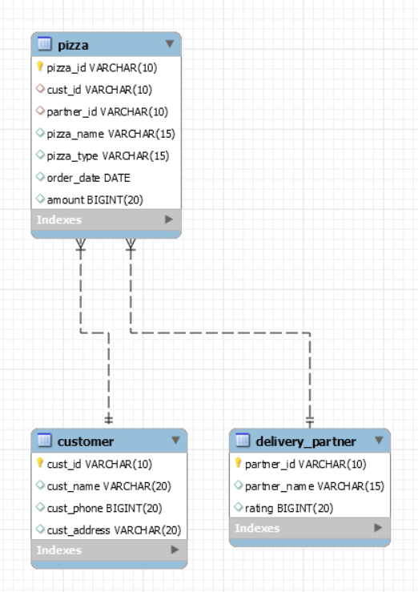

select PIZZA_NAME, COUNT(MAX(PIZZA.CUST_ID)) AS NO.SOLD FROM PIZZA, CUSTOMER WHERE PIZZA.CUST_ID = CUSTOMER.CUST_ID;